Long Live “The Queen of Memphis”
Hurdles await, but Stuart Harris — the Sterick Building’s biggest fan — has a bold vision for the Downtown landmark.
by Samuel X. Cicci
July 4, 2023

8:00 AM

Print
Expand
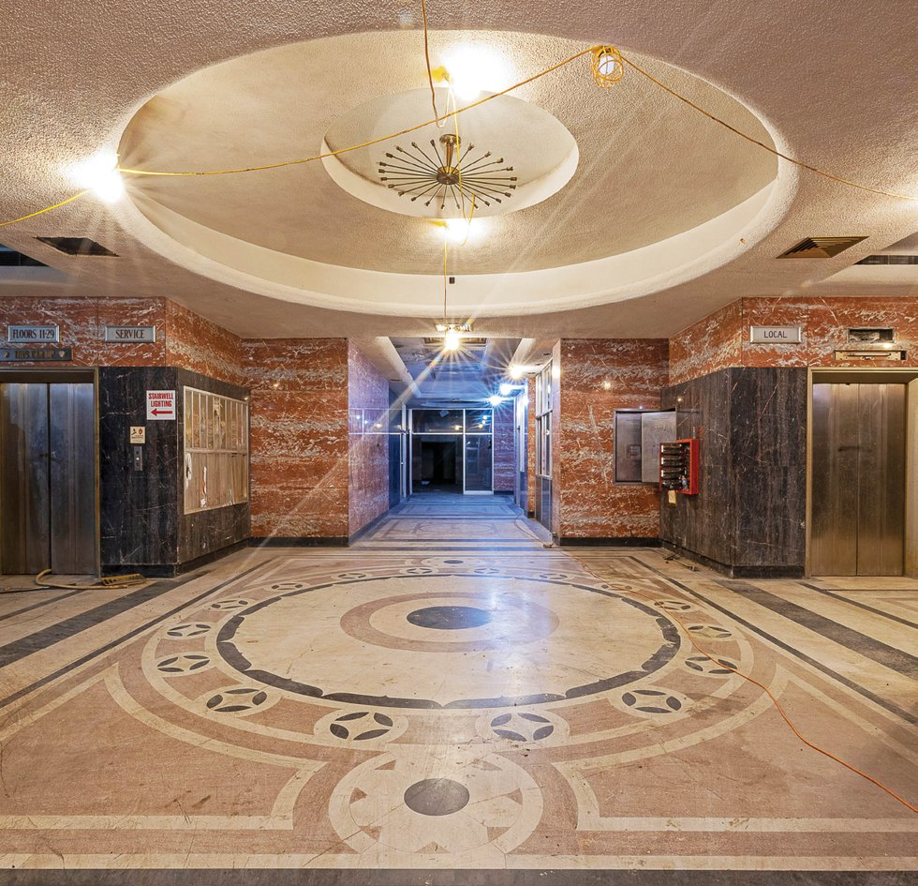
PHOTOGRAPH BY JUSTIN FOX BURKS
As you’ve probably heard, once again the Sterick Building has new owners. This time, though, the story may have a happier ending. The mustard-yellow (for now) 29-story skyscraper that has towered over Downtown Memphis for the better part of a century, looking rather forlorn in recent decades, might finally move into the modern era of Memphis thanks to Stuart Harris, principal at Constellation Properties. A longtime admirer of the building, Harris views the Sterick as the crown jewel of Downtown and harbors ambitious plans to revitalize the busy corner of Madison Avenue and B.B. King Street (formerly South Third) with retail, hospitality, and multifamily residences. Getting his hands on the deed to the property was an odyssey in itself, but with that hurdle cleared, the real work is ready to begin.

A Done Deed
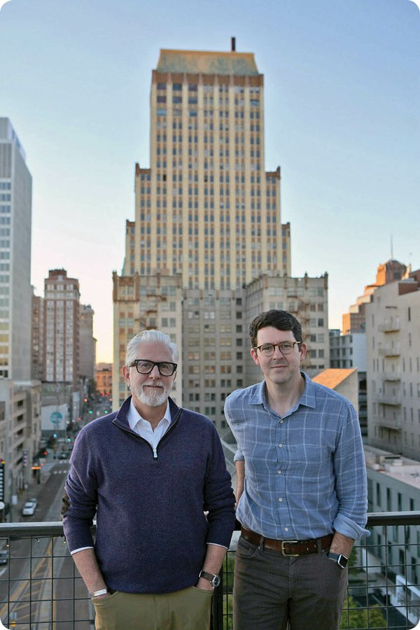
PHOTOGRAPH BY CATHERINE BURNS
Michael Cook (left) and Stuart Harris with Constellation Properties. Their newest project looms behind them.
A native Memphian, Harris has worked in and around the real estate industry for decades with roles at CBRE and SouthernSun Asset Management. He’s touched several other Downtown redevelopment projects, but his March 31, 2023, acquisition of the Sterick Building elicited cheers from some, and raised eyebrows from others. Was Harris’ plan to tackle a project that so many developers had avoided a stroke of genius, or folly? After all, the long dormant building — empty for more than 30 years — is 340,000 square feet, making it a massive renovation effort.
“Some time ago, we among others were invited to tour it,” says developer and real estate expert Henry Turley. “And at the time, a lot of us said this can’t be developed without the parking garage and a hotel next door. Then you look at previous owners like the Gilliland family who did everything right, but still punted on it.”
The challenge didn’t deter Harris. While others might have a vested interest in redeveloping community assets, he harbored a passion, almost an obsession, with the tower, even going so far as to commission a Sterick-themed wedding cake back in 2006.
Untying the Gordian ownership knot and solving the land-versus-lease issue had long been a major impediment for any parties even vaguely interested in pursuing a revitalization project. “From the minute that the Sterick lease was transacted [in 1926], everything put on that land didn’t belong to it until April 30, 2025,” says Harris. “When that lease expired, everything would return to the landowners.” Harris is referring to the Grosvenor Estate, the descendants of Napoleon Hill, the millionaire whose mansion previously stood on that site. “With ownership changing hands over the years, many of them didn’t care about maintaining the space with that in mind. And then when you saw Downtown depopulating in the ’70s and ’80s, there wasn’t a lot of demand for a space like the Sterick.”
But even as Downtown development picked up pace again in recent decades, there was always a Catch-22 lingering over any plans to spruce up the Queen of Memphis. The lease requirement to turn the building back over to the Grosvenor Estate in “good working order” remained far enough away not to be too concerned about, but that same 2025 deadline meant that any improvements made to the building wouldn’t be worth the investment for developers.
If Harris wanted to make a deal happen, he needed to bring both the Grosvenor Estate and Equitable Life to the negotiating table and get both to buy into his pitch. He had both passion and a particular confluence of events that helped clear his path to ownership. For one, he already had a personal relationship with Henry Grosvenor, a member of the ownership trust, and started pitching his ideas for the Sterick in the first quarter of 2021. Plus, with the 2025 deadline in the back of everyone’s minds, the City of Memphis and local organizations like the Downtown Memphis Commission started putting more pressure on all parties to come to a resolution, rather than spending time in legal wranglings over whether or not the property was in “good working order.”
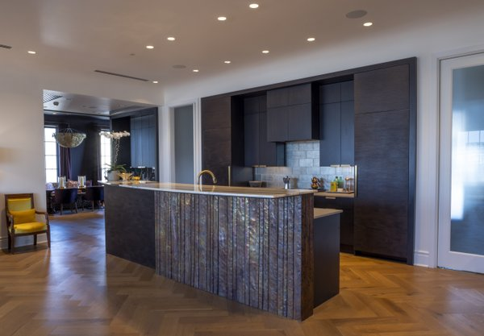
PHOTOGRAPH BY JUSTIN FOX BURKS
Inside The Commonwealth, the building just down Madison from the Sterick, which Harris and his partners purchased and fully restored.
Harris also had a “proof of concept” just down the street at 240 Madison that backed up his aspirations. In 2018, he finished redevelopment of the former Medical Arts Building on behalf of lead investor Michael Cook, founder, CEO, and co-chief investment officer of SouthernSun Asset Management. Now dubbed “The Commonwealth,” the eight-story mixed-use development is a template for the kind of restoration Harris envisions for the Sterick.
The Commonwealth, which had been empty since 1971, is now home to offices, 40 apartments, a coffee shop (Boycott Coffee), and a soon-to-be-announced new restaurant. Artwork on the ground floor, including custom murals depicting the building’s life in the ’20s and a large map of Downtown Memphis, pays homage to the neighborhood’s history. “We definitely look to reuse as much as we can in our projects,” says Cook, a key player alongside Harris in the Sterick project. “With the Commonwealth, there were a lot of items left over in the basement, which was originally a public Civil Defense bomb shelter from the 1950s. We found C-rations and old bomb shelter signs down there, and brought artists in to make artwork out of those materials. It’s about maintaining that connection to the past, and then bringing it forward so that people feel like they’re a part of it.
“We definitely took some lessons from working on the Commonwealth,” adds Cook. “There’s less margin for error on a project like that since it was a smaller space, and we ran into issues and had some challenges with retrofitting. But it helped because it was built in a similar era [1926], and had similar construction. So those learnings will be really valuable as we translate that experience into the Sterick Building.”
As he continued to pitch his vision for the Sterick, Harris challenged both the land owner and leaseholders individually, and tried to work out what type of arrangement would end with everyone happy. Helping throughout the whole process has been Stuart’s father, Michael Harris, known in Memphis as a real estate veteran and former longtime COO of Highwoods Properties, who has lent his expertise to help the Sterick project move forward.
While the parties have not disclosed the specifics of the sale, the result was a title in hand for Harris and Constellation Properties, complete control of his dream property, and no further legal obligation to have the building in “good working order” by 2025.
Expand
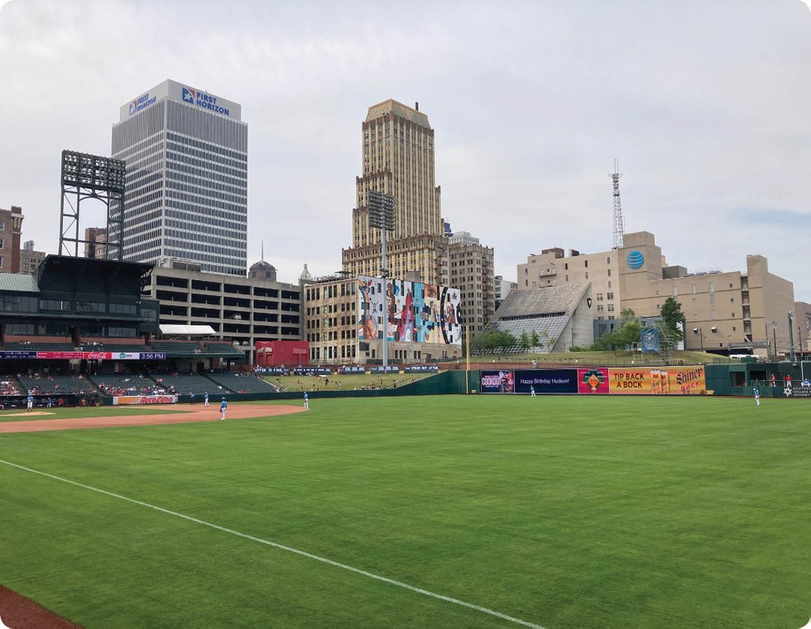
PHOTOGRAPH BY FRANK MURTAUGH
Once the building is restored, residents will have a fine view of AutoZone Park.

The Sterick’s Fit Downtown
If Harris’ big gamble pays off — time will tell — the Sterick Building is poised to be a tremendous asset to Downtown Memphis. The Madison corridor has come a long way in the past couple of decades, and a quick glance around can tell any casual observer why. Locals can be seen strolling up and down the block, perhaps heading to the nearby YMCA or across the street to catch a Redbirds or 901 FC game at AutoZone Park. Multiple coffee shops, such as Boycott and Crazy Gander Coffee Company, welcome Downtown office workers and visitors. Restaurants along the Main Street Mall are just minutes away. And big projects, like the revamped Tom Lee Park and the Downtown Brooks Museum currently under construction, will likely draw even more visitors to the riverfront.
It’s clear that people want to play Downtown, but there are many who want to live and work there, too. Harris’ plan for the new Sterick is to make it a hive of multifamily apartments, possibly accompanied by a boutique hotel, retail options, and restaurants. But even with so many apartments and hotels springing up around Downtown (and more on the way), Harris and Cook are confident that the city can accommodate more units.
A Zimmerman/Volk Associates (ZVA) housing market study commissioned by the Downtown Memphis Commission in 2021 backs up those claims. “Based on regional household growth, mobility, and other market trends, ZVA projects that Downtown has the potential to absorb between 6,000 – 7,000 market-rate housing units in the next decade,” reads the study. “Due to the high need in the Memphis region, demand for affordable housing units Downtown is extremely high.
“If 30 percent of new housing units are made affordable — which would require significant public investment — up to 10,000 new housing units (7,000 market-rate and 3,000 affordable) could be absorbed by the end of 2030,” continues the report. “This is over twice the total units added since 2000 — holding the potential to dramatically reshape Downtown.” Henry Turley Company’s new Orleans Station apartments, just up the road in the Edge District, to name one recent example, opened at maximum occupancy. The demand for more units in the area remains hot.
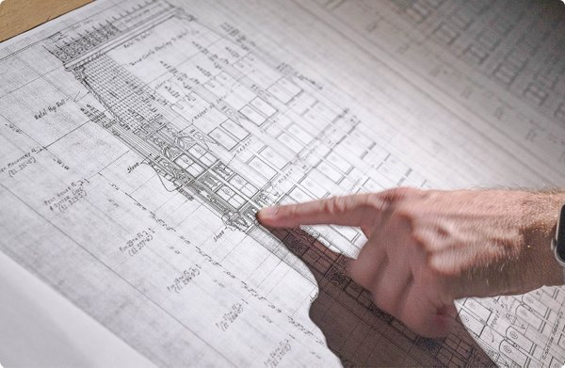
PHOTOGRAPH BY JUSTIN FOX BURKS
Harris points out a detail on the Sterick Building plans.
As it’s still early days for the project, plenty of crucial details are yet to be hammered out. But Harris envisions the Sterick with a range of anywhere from 140 to 260 total apartment units. “We’re balancing the civic-mindedness of the project against profitability,” says Harris. “We’re analyzing where the apartments should sit, and where they might be the most profitable. So right now, we’re focused on our programming, modeling, and cost projections to make sure what we decide is sustainable.”
Harris and Cook are also exploring the idea of adding a boutique hotel, if they deem it financially viable. “The space is big enough to accommodate that,” says Harris. “And that’s something else to consider: Where do we put the hotel, and how does it interact with [the apartments]?” If a hotel does come to fruition, there will likely be plenty of visitors. According to Memphis Tourism’s 2022 annual report, the Memphis metro area sold over 6 million hotel room nights, an increase over 2021’s 4.1 million rooms. If anything, the Sterick Building could provide yet another option for conference-goers at the new Renasant Convention Center. (A convention-specific hotel has yet to reach fruition.)
Developers speak of “activating” certain areas, but Harris and Cook are pouring their resources into Madison, having purchased additional parcels of land between the Sterick and Commonwealth buildings, and have deals in the works for several more in the surrounding area. “I like to view this unofficially as the Commonwealth neighborhood,” says Cook. “The motivation here is to do things with quality and with a long view. And we were actually content with the notion that we might not get the Sterick. We knew something might happen in 2025 if we didn’t, but it became about, how do we continue to operate in such a way that we’re … bringing life to the spine of Downtown.”
“Now, when we look at the connective tissue that something like the Sterick does for the broader neighborhood between the Downtown core and the Edge,” says Harris, “we’re kind of closing our eyes and envisioning a neighborhood that has some pretty awesome structures like the YMCA, the ballpark, Visible Music College, Downtown Elementary School, yet also has blight and a bunch of surface parking lots.”

Next Steps
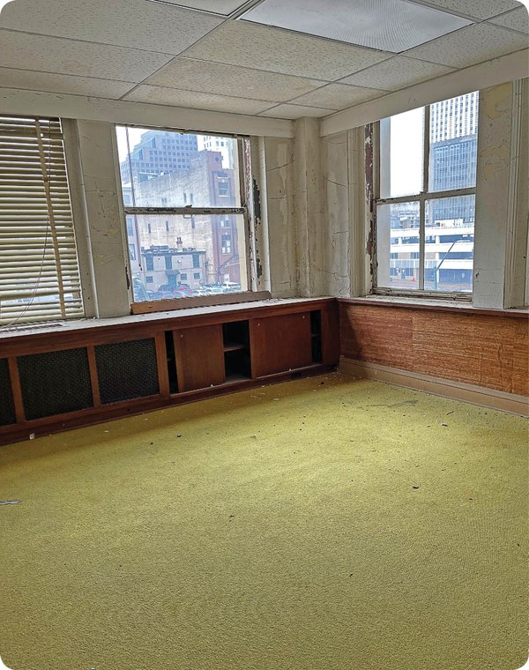
PHOTOGRAPH BY ANNA TRAVERSE FOGLE
Many of the offices retain their 1960s — or maybe it’s 1970s — feel. Renovation plans call for the removal of all the old carpet, exposing the original terrazzo tile floors.
Harris can already imagine the joy that his revamped Sterick might bring to Downtown. But first, the building needs more than a little TLC. And for that, it also needs additional financing.
A trek up the tower’s 29 stories leaves visitors with visions of a post-apocalyptic Mad Men. The lobby’s tile floor has remained marvelously intact, a beautiful invitation into the city’s first skyscraper. But farther up, footsteps frequently sink into squishy carpeting and rotting floorboards of a blighted interior. The ceilings and walls are riddled with gaping holes, black mold makes frequent appearances, and the asbestos-filled walls need addressing.
Elsewhere, shag carpet, zebra or bamboo wallpaper, and paint color decisions that were probably very chic in the ’60s abound, conjuring the image of a “no rules” approach to design. Rushed drop-ceiling HVAC installations from the ’50s, according to Harris, make rooms feel claustrophobic. All of the electrical, plumbing, and mechanical components of the interior will need to be redone. In essence, the interior will be like a completely new building if the project runs to completion. But it’s not an insurmountable project. “The damage inside is something that can be overcome,” says Turley. “What they’ve got to do is make it conform to the new use.”
And the exterior might get a shiny new glow-up, as well, with Harris mulling plans to restore the building’s current faded-yellow visage to its original stone facade. “It used to be stone, then it was white,” adds Turley. “The yellow just never worked. You’ve got the Shrine Building, the William Len Building, and 81 Madison; they’re all stone, and they look right. That’s the way it’s supposed to be.”
Harris acknowledges many of the concerns about the Sterick, but prefers to focus on what the building could be, rather than what it is now. “A lot of the damage is superficial,” he says. “The building itself is made out of concrete and steel, with a composite limestone exterior. It’s a beautiful historic shell in pretty good condition. Then, even under all the flooring, rip that up and you’ll still have marble and terrazzo floors underneath. We’ll leave that intact as much as we can, and actually did a similar thing at the Commonwealth.”
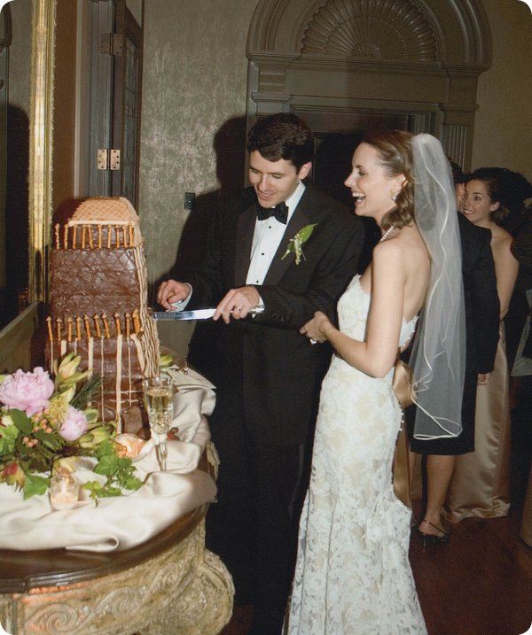
PHOTOGRAPH COURTESY OF STUART HARRIS
Harris has been such a fan of the Sterick Building that he even had his wedding cake designed to resemble the old yellow-and-brown building.
The first order of business for Harris and Cook is eliminating all the asbestos. But the next year-and-a-half, they speculate, will be dedicated to architectural and engineering plans. “Schematic designs and programming, things like that,” says Harris. “At the same time, we’ll be pricing the job, since construction costs are way up right now, and working on financing. We’re going to be working lockstep with the National Park Service and the State Historic Preservation office to make sure that we don’t get ahead of anybody, since we’ll be utilizing federal historic tax credits on this project.”
After the 18-month planning period, Harris predicts another 18-24 months of construction. If everything goes smoothly, he hopes to deliver a revamped Sterick Building by the third or fourth quarter of 2026. “But a lot of things can happen between now and then,” he says.
If — and at this early stage it’s definitely an if — all goes well, the Queen of Memphis may reign over Downtown once more. And Harris won’t have to settle for a Sterick wedding cake. He’ll have the real thing, and perhaps even a unit of his own. “I can’t imagine not having a place in there once it’s done, even if it’s in the basement,” he laughs.
See part one of this story, "The Story of the Sterick Building: The Rise and Fall of the Queen of Memphis.

